**New SUNY Funding Available for Student Research Support**



**for Summer 2024, Fall 2024 & Spring 2025!**

**Apply by April 17th!**

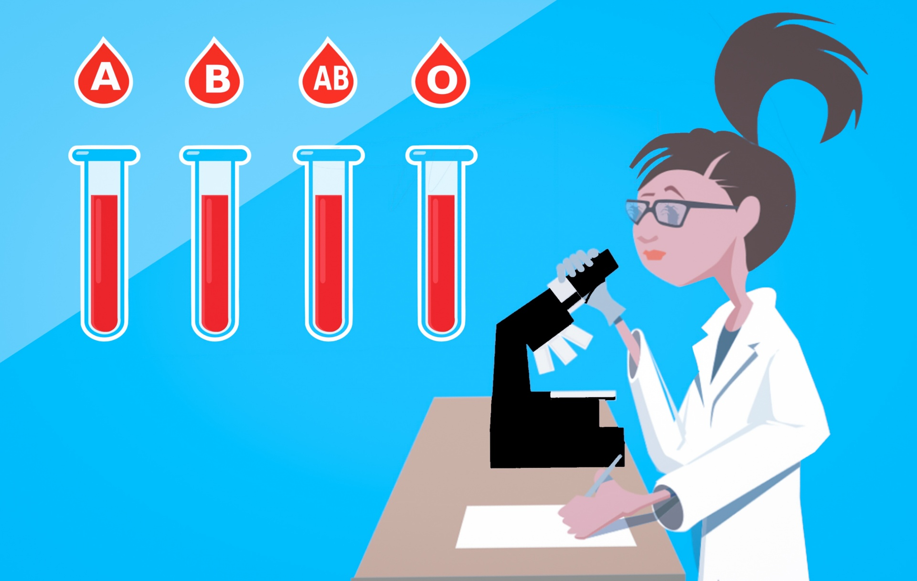

New SUNY funding is now available for:

* student research assistants on faculty research or
* students working on independent research with a faculty sponsor!

What is the time frame for Student Research Support?

* Time Period #1: May & June 2024
* Time Period #2: Fall 2024 semester
* Time Period #3: Spring 2025 semester

Who is eligible to receive these research fellowships?

* Faculty members should submit applications on behalf of potential students

What is the total amount to be awarded for Student Research Support?

* For Time Period #1: $25,000
* For Time Periods #2 & #3 combined: $25,000

How much support can each student researcher receive?

140 hours @ $15/hour undergraduate students, $19/hour for graduate students

* AY Stipends for up to 10 hours per week for 14 weeks
* Summer stipends for up to 140 hours (e.g., 4 weeks x 35 hours or 7 weeks x 20 hours)
* Support for research materials up to $1,000 per student, maximum of $3,000 per project

What type of research can be funded in these grants?

* Research in the sciences, humanities, and professional studies (all disciplines eligible)
* All stages of the research process are eligible

What is the deadline for submitting applications?

* For full consideration, applications & proposed budgets for all 3 Time Periods should be submitted by April 17, 2024.
* Applications should be submitted via the following Google form:

<https://docs.google.com/forms/d/e/1FAIpQLScmJIPonAWUMKzPf1drm88UeiLlmLOVVtdpuu6eZI-6gstD2w/viewform>