Congratulations to all the presenters!  Thank you to everyone attending for your support.  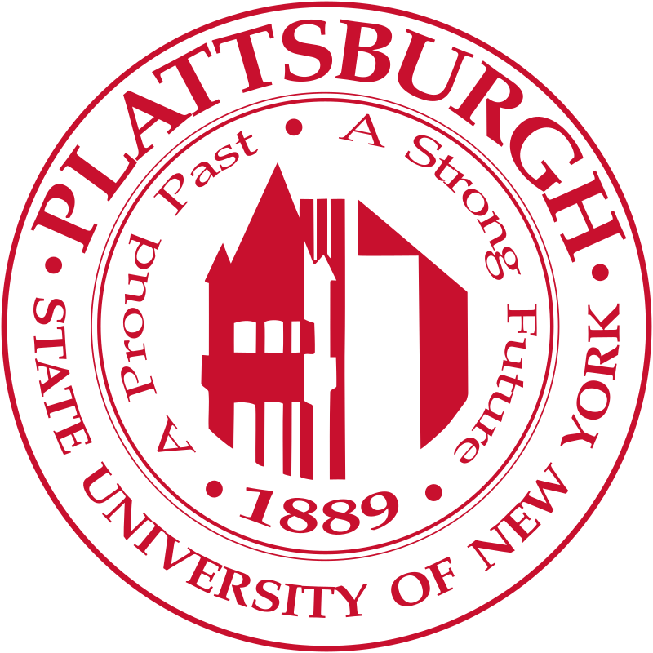  Congratulations Fall 2024 Graduates!! |  |  | SUNY Plattsburgh History Department  “Senior Presentations”  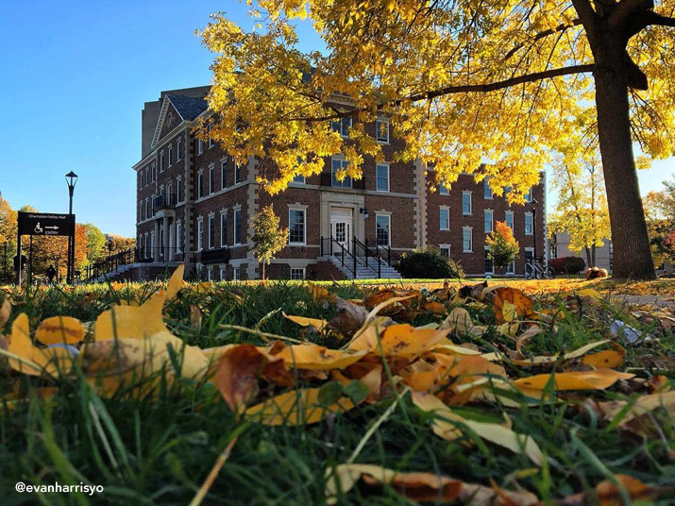  December 6th, 2024  - Alumni Conference Room

Schedule:  8:50 Welcome & Introduction  9:00 Riley Tamer  “Reform and Rebellion: Speransky, The Decemberists, and The Fractured Liberalism of Early Nineteenth Century Russia”  9:20 Hayden Exford  “Interwar Britain and the Support for Oswald Mosley's British Union of Fascists”  9:40 Dylan Smead  “U.S. and Japanese Textbooks: Narratives Shaped  By Historical and Cultural Differences”  10:10 Matthew Gannon  “Florence Nightingale and the Light Brigade: A Juxtaposition of Crimean War Heroes”  10:30 Kiersten Brown  “Social Practice in Medieval France as Seen Through Art: An Exhibition”  Kiersten Brown  Social Practice in Medieval France as Seen Through Art: an Exhibition  12:10 – 1:15 LUNCH (see following page) |  |  | 11:00 Jerrique Ortiz  “Leroy Stover in Context: Unpacking the Life and Legacy of Leroy Stover and the Birmingham Police Department”  11:20 Cooper Scherer  “Rime of the Arctic Mariner: The Search for Franklin's Lost Expedition, a Novella”

