Civic Learning Through a Lens of Racial Equity Workshop
Thursday, May 30, 2024
8am to 4pm in SUNY Cortland’s Corey Union’s Exhibition Lounge

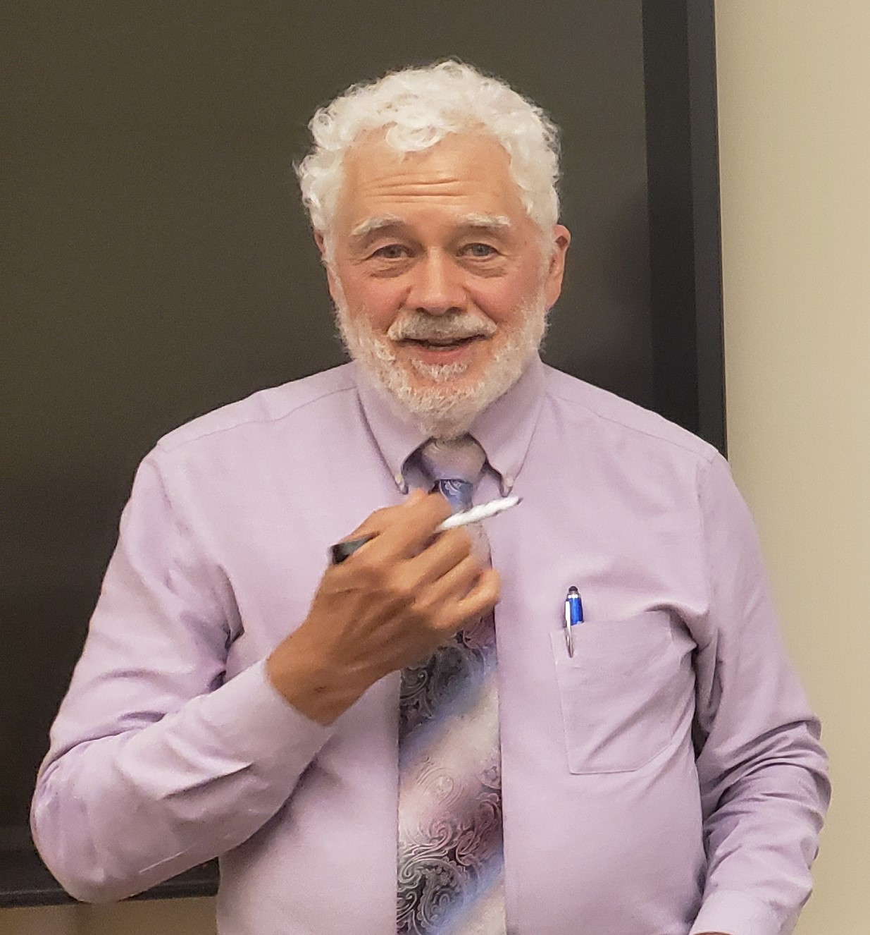
Our Facilitator, Dr. John Reiff, is
- Director of Civic Learning and Civic Engagement, Massachusetts Department of Higher Education.
- Equity and Engagement Fellow, Campus Compact.
- Co-editor of Anti-Racist Community Engagement: Principles and Practices (2023), for which he and his colleagues were awarded the International Association for Research on Service-Learning and Community Engagement’s Diversity, Equity, and Inclusion Award.
This strengths-based workshop is for faculty, staff, and administrators who want to blend civic learning, racial equity, and student resilience into their work.

The workshop’s objectives: Participants will –
- Explore the importance of civic identity and active listening skills in learning that is related to racial equity and civics.
- Incorporate (into an existing syllabus or institutional document) listening skills and concepts related to civic identity, racial equity, and student resilience.

Method. The event uses discussion, activities, and group work across four sessions:
- Creating a Civic Identity – Each participant explores their individual civic identity as a step in helping students develop their own civic identities.
- Identifying Skills for a Multiracial Democracy – Participants examine their active listening skills and ways in which they apply those skills in interactions with students and others.
- Identifying Democratic Knowledge and Levers of Change. Participants analyze syllabi and other documents for those items’ civic learning and racial equity content and methodology.
- Shaping syllabi and other institutional documents to include Practical Experience with Communities On and Off Campus. Participants use active listening skills to workshop their respective documents to incorporate racial equity, resilience, civic learning, and applied learning.

In so doing, we meet at least two of SUNY Chancellor John King’s Four Pillars (in bold) –
- Student Success  - Research and Scholarship | - Diversity, Equity, and Inclusion  - Economic development and upward mobility

Notes.
- To register, email john.suarez@cortland.edu by Friday, May 3, and attach, as a Word or PDF document, the syllabus or institutional document that you would like to work with.
- Participants are expected to engage in the full workshop.
- At the completion of the workshop, participants will receive a certificate acknowledging their work.
- Refreshments will be provided –
  - Coffee and a continental breakfast, 8:00am to 8:30am.
  - Lunch.
This event is sponsored by SUNY Cortland’s Institutional Equity and Inclusion Office, the Anti-Racism Task Force, and the Institute for Civic Engagement. It is made possible through a generous grant from the Institutional Equity and Inclusion Office, and with help from the Institute for Civic Engagement.

