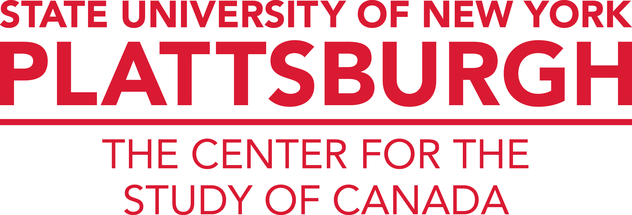 | 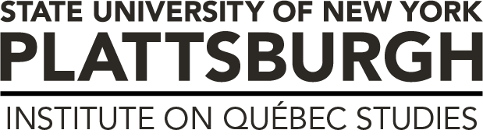

2023-24 Course Development Stipend Opportunity

The Center for the Study of Canada/Institute on Québec Studies invites SUNY Plattsburgh faculty to apply for a course development stipend to enhance course offerings with Canadian or Québec content. Faculty who meet the necessary requirements outlined below will be provided with a summer stipend through the Research Foundation at SUNY Plattsburgh in the amount of $2,000 or $3,000. A limited number of awards are available under this program.

The Center/Institute is pleased to offer this stipend to contribute to the growth, regeneration, and sustainability of a strong cohort of faculty engaged in Canadian Studies at SUNY Plattsburgh. This stipend opportunity is designed to support faculty who are interested to significantly revise existing courses and/or develop new three-credit, undergraduate courses with Canadian content to be taught with regularity. An expectation of those who receive this stipend is to teach the revised or new course within one to two years of its development and approval. Recent hires to the university who are interested in teaching courses that include Canadian topics are particularly encouraged to pursue this opportunity. Stipends will be granted to faculty to support the revision of an existing course in the amount of $2,000 and to support the development of a new course in the amount of $3,000.

ELIGIBILITY
Faculty who are tenured or tenure-track will be considered for this opportunity. Individuals who have not received course development funds from the Center in the past will be accorded clear preference.

REQUIREMENTS
Significantly revised or new courses must contain a minimum of one-third Canadian or Québec content. Funding priority will be given to the development of regular, classroom courses that focus on teaching and research of significant Canadian content. Experimental courses may also be considered, but will not receive funding priority. Courses to be included in the Cardinal Core Curriculum are encouraged.

All work on the newly constructed course must take place between May 20, 2024 and August 2, 2024.

Stipends will be paid in late August 2024, provided the obligations listed below are fulfilled and the following documentation is provided to the Director, Center for the Study of Canada/Institute on Québec Studies:

- The revised or newly constructed master course outline and syllabus must be submitted. The syllabus must include a detailed course outline, including thematic topics, a reading list, and/or select bibliography.

- A brief, one-page report explaining how the revised or newly constructed course fits into the curriculum offerings of their respective department and how the course can be expected to contribute to the curriculum for the Canadian Studies minor, Québec Studies minor and/or other applicable academic program(s). The report should also note any recommended action for program revision to curriculum requirements of any academic programs to include credit for the revised or newly constructed course.

- All significantly revised or newly constructed course syllabi must be formally cross-listed with the Canadian Studies Academic Program by featuring an appropriate CAS course number.

- Confirmation that the revised or newly constructed master course outline and syllabus will be/has been formally submitted for official approval by the appropriate Dean, School-level Courses and Programs Review Committee, and Office of the Provost to ensure the course is listed in the SUNY Plattsburgh course catalog.

Please note that all Center supported course development stipend projects require pre-approval from the Director of the Center for the Study of Canada/Institute on Québec Studies. To discuss your interest in this opportunity and any related questions, please contact Dr. Christopher Kirkey, Director, Center for the Study of Canada/Institute on Quebec Studies, SUNY Plattsburgh, 133 Court Street, Plattsburgh, NY 12901 (kirkeycj@plattsburgh.edu; 518.564.2394).

