SUNY Plattsburgh History Department  “Senior Presentations”  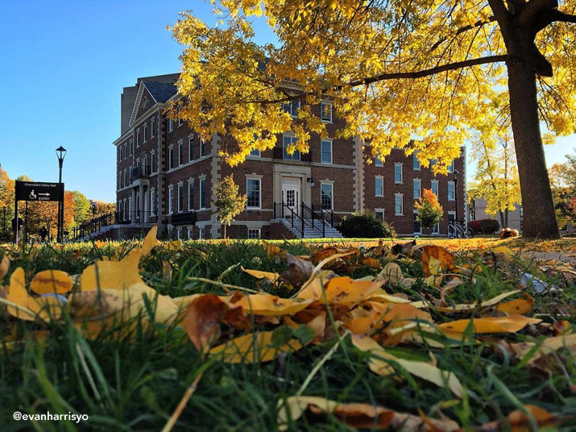  December 8th, 2023  - Alumni Conference Room |  |  | Schedule:  10:10 Welcome & Introduction  10:15 Brandon Doty  Crucial Institutions: A Historiography of the American Occupation of Japan.  10:40 Ben Hammond  Unearthing ‘Wonderful Things’: Howard Carter as an Explorer.  11:05 Ben Catrambone  A Nation of Shopkeepers at War: British Medical Organizational Innovations in WW1.  11:40 Noah Lederman  Government is the Problem: Ronald Reagan and the War on Drugs.  12:10 – 1:15 LUNCH (see following page)

1:30 Frank Cronin  Truman Seymour – a Life of Art and Service.  1:55 Zach Johnson  Chavez Ravine: The Importance of Home Ownership.  2:20 Stephen Bedard  What Now, What Next? The Closure of the Plattsburgh Air Force Base. |  |  | 