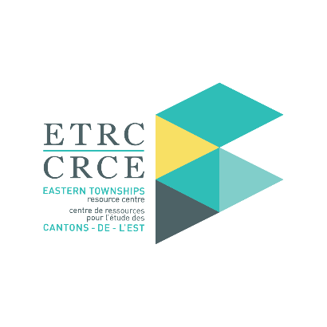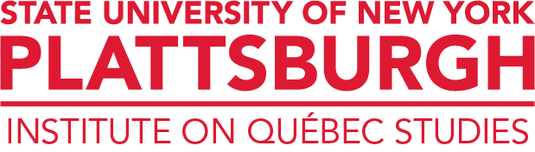

CALL FOR PAPERS/COLLOQUIUM

FACULTY AND STUDENTS

We are pleased to announce this call for papers for the 12th Colloquium on Quebec Studies to be held at Bishop’s University on March 15 – March 16, 2024. The title and overarching theme of the conference is *Quebec Past and Present*. We invite researchers, academics and students from all disciplines in humanities and social sciences to contribute to this international and multidisciplinary colloquium. We are most interested in contributions from history, sociology, political science, public policy, linguistics, education, health, literature, art and architecture. Paper proposals, in English and French, will be accepted from undergraduate/graduate students and faculty from all universities. We especially encourage faculty to identify and encourage talented students to submit a proposal for consideration.

If you are interested in submitting a proposal, kindly send your abstract (max. 300 words) and vitae before February 15, 2024. Please submit your proposal to [etrc@ubishops.ca](mailto:etrc@ubishops.ca).

All submissions will be reviewed and individuals will be contacted no later than March 1, 2024 regarding their submission.

To facilitate your involvement in this project, we are pleased to provide the following support to those SUNY Plattsburgh individuals selected to participate:

* Breakfast, breaks, lunch, and dinner on Friday, March 15, 2024
* Breakfast, breaks, and lunch on Saturday, March 16, 2024
* Two nights lodging in Sherbrooke – Thursday, March 14 and Friday, March 15
* Roundtrip transportation

This initiative is being sponsored by Bishop’s University, the Eastern Townships Resource Centre, the Institute on Québec Studies at SUNY Plattsburgh, the United States Department of Education and the Québec Ministry of International Relations and la Francophonie.

COLLOQUIUM ORGANIZERS

Christopher Kirkey, Ph.D.

Director, Institute on Québec Studies (IQS)

State University of New York (SUNY) Plattsburgh

Cheryl Gosselin, Ph.D.

Professor, Dept of Sociology

Bishop’s University

Jody Robinson

Executive Director,

Eastern Townships Resource Center (ETRC)

Bishop’s University