SUNY Plattsburgh History Department  “Senior Presentations”  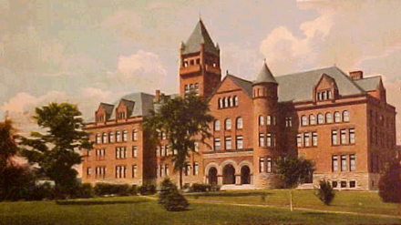  MAY 12th, 2023  - Alumni Conference Room |  |  | Schedule:  8:00 Abigail Putnam  “Why we teach the Haitian Revolution”  8:20 Jason Koginos  "Tombs in the Artic: The Lost Franklin Expedition and Visions of Heroism"  8:40 Ben Dupree  “The Louisiana Purchase, Was it Constitutional?”  9:00 Owen Graff  “Feudal Society”  9:20 Paige Blanda  "My Daughter, My Mind, and Me: Changes in Treatment of Schizophrenia from the 1950s to the 1970s" (Historical Fiction)  9:40 John Bergin  “Muckrakers V.S. The World”  10:00 Logan Valerio  “FDR and the New Deal: Reigniting America's Confidence”

10:20 Redia Spada  “Lines in the Sand: The Impact of the Partitioning of Africa”  10:40 Zane Ovitt  “The Shifting Paradigm: The Agricultural and Industrial Revolutions in 18th Century England  11:00 Connor O’Neil  "The Rush for Gold: Boomtowns on the Alaskan Frontier" (Historical Fiction)  11:20 Stephen Dixon  "Jackie Robinson, More Than Just a Ballplayer"  11:40 Kassandra Sherman  "Cultural Appropriation or Appreciation?:Victorian British use of Kimonos"  Break  1:20 Rose Wise  "The FBI Vs. The John Birch Society" |  |  | 1:40 Culum Thompson  "The COYOTE Movement: Perspectives on Prostitution from the 1970s"  2:00 Natalie Bouvier  “Welcome to New Netherland, Want to Go Dutch?”  2:20 Weston Sweet  "A Geography Lesson, and Why We Must Teach Geography"  2:40 Catherine Ficke  “FDR’s New Deal and Government Intervention”  3:00 Sean McInerney  “Regarding the teaching of the Federal Reserve”  3:20 Alex Miller  “The Waterways of Greece: A Lesson in Shipbuilding”  3:40 Mary Skulan-Toran  "Analysis of Sakura’s Representation in Fanfiction: What This Says About Fan Reception of Female Representation in Shonen Anime"

