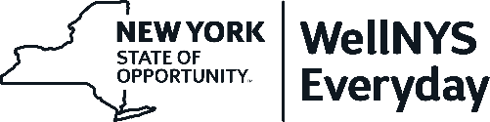

**WellNYS Everyday Monthly Webinar:**

**"Do More of What Makes You Happy:**

**How to Incorporate One Positive Thing into your Day."**

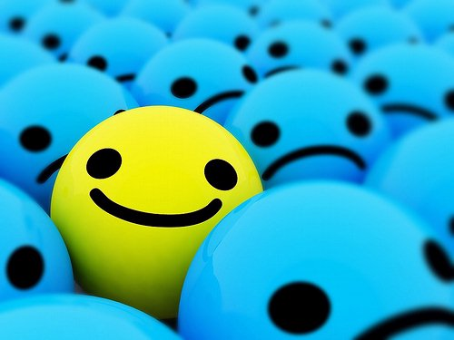

The WellNYS Everyday Monthly Challenge for November is to “Plan one positive thing for tomorrow.” Did you know that spending just five minutes a day practicing positivity can help boost your mood, build resilience, experience more joy, increase motivation, and decrease negativity?

This webinar will familiarize you with how positive emotions, engagements, relationships, meaning, and accomplishments increases happiness and enables you to flourish and thrive in life. You’ll walk away with concrete tools for managing stress, experiencing more positivity, and feeling more energized, peaceful, and connected.

**Wednesday, November 2, 2022**

12:00 Noon – 12:30 P.M.

Presented by

**Amy Bidwell, PhD**

Professor

State University of New York at Oswego

**To register for this training session**   
Go to <https://meetny.webex.com/meetny/k2/j.php?MTID=t6a942d5f8ac984da01c8046ab2cdaff5> and register.   
  
You will receive a confirmation email with instructions for joining the session.

This session will be recorded and made available on the WellNYS Everyday website.

Work-Life Services (WLS) Programs are joint labor-management programs that benefit New York State employees by enhancing employee wellbeing, increasing productivity, and improving morale in the workplace. The WLS programs include the Employee Assistance Program, Network Child Care Centers, and DIRECTIONS: Pre-Retirement Planning. The WLS programs are funded through the collective bargaining agreements between the State of New York and the public employee unions:CSEA, PEF, UUP, NYSCOPBA, GSEU, Council 82, and DC-37 and PNANYS. The Office of Employee Relations contributes on behalf of management/confidential employees.