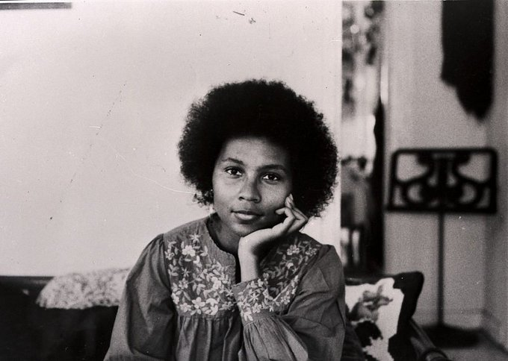

# bell hooks

**Writing Prize**

**in**

**Gender & Women’s Studies**

The Gender & Women's Studies Department at the State University of New York College at Plattsburgh is pleased to announce the inaugural bell books Writing Prize in Gender & Women's Studies, a prize awarded for an outstanding paper on a topic relating to how gender intersects with other social locations such as race, ethnicity, nation, class, sexuality, age, (dis)ability, religion, and culture. Entries should be major essays or research papers (at least 1000 words in length). **This year's Writing Prize, which will be presented at the Arts and Sciences Academic Achievement Awards Ceremony on May 20, 2022, carries with it a cash award of $100.** We gratefully acknowledge support from the Plattsburgh College Foundation.

Rules of eligibility and procedures for submission:

1. Students must be enrolled as an undergraduate at SUNY Plattsburgh or plan to graduate in May 2022 or December 2022.

2. The entry must have been prepared originally for an undergraduate course taken at SUNY Plattsburgh during the student’s baccalaureate program. Students may revise papers prior to submission for the Writing Prize.

3. The entry may be in any field--humanities, social sciences, science, or professional studies--but the topic must directly address gender and intersectionality.

4. The entry must be typed, double-spaced, and must not bear the name of the author. To submit, email your entry to Jennifer Bleaux at [blea9777@plattsburgh.edu](mailto:blea9777@plattsburgh.edu) by the final deadline. Papers will be judged anonymously by the Writing Prize Committee. Judging criteria include conceptual development, organization, and style.

5. **The final deadline for submission is Friday, April 1, 2022, 3:00pm.**