2026 National Day of Racial Healing Schedule of Events

Tuesday, January 20, 2026 SUNY PLATTSBURGH

9:00 AM Update Your Email Signature, Take a Photo with the DEI backdrop, and tag #HowWeHeal for social posting.

Location: Warren Ballrooms in Angell College Center (ACC). Photos can be taken and posted throughout the day!

9:30 AM Doors Open, Info Tables & Refreshments Available

Location: Warren Ballrooms, ACC

10:00 AM Campus Kickoff & Keynote Presentation
Event Theme: "How We Heal"
Keynote Speakers: Dr. David Fryson

Location: Warren Ballrooms, ACC
ZOOM: https://plattsburgh.zoom.us/j/82870580473?jst=2

11:00 AM Concurrent Sessions A

Title: Understanding Your Trauma Story
Presenter: Jacqueline Madison

Location: Alumni Conference Room, ACC

ZOOM: https://plattsburgh.zoom.us/j/82870580473?jst=2

Title: No Hate NYS: Hate and Bias Prevention in NY
Presenter: Ron Zaachi, Hate and Bias Prevention Unit

Location: Cardinal Lounge, ACC

12:00 PM Lunch, Networking, and Roundtable Discussions

Location: Warren Ballrooms, ACC

Join the TRHT Team and other community members in small group discussions over lunch. Topics will be displayed at each table for you to choose from. If you are interested in hosting a table please reach out to thompsma@plattsburgh.edu.

1:00 PM Leading Healing Discussions

Title: Utilizing the TRHT Circle Methodology
Presenter: Mike Thompson & Michelle Bonati
Location: Warren Ballrooms, ACC
ZOOM: https://plattsburgh.zoom.us/j/82870580473?jst=2

2:00 PM Concurrent Sessions B

Title: Racial Healing Circle (In-person)
Facilitators: TBD
Location: The H.U.B., ACC

Title: Racial Healing Circle (Virtual)
Facilitators: Bridget Haina & Mike Thompson

Location: Virtual
ZOOM: https://plattsburgh.zoom.us/j/82870580473?jst=2

3:00 PM Gratitude

Final Remarks & Thank You to All

Location: Warren Ballrooms, ACC
ZOOM: https://plattsburgh.zoom.us/j/82870580473?jst=2

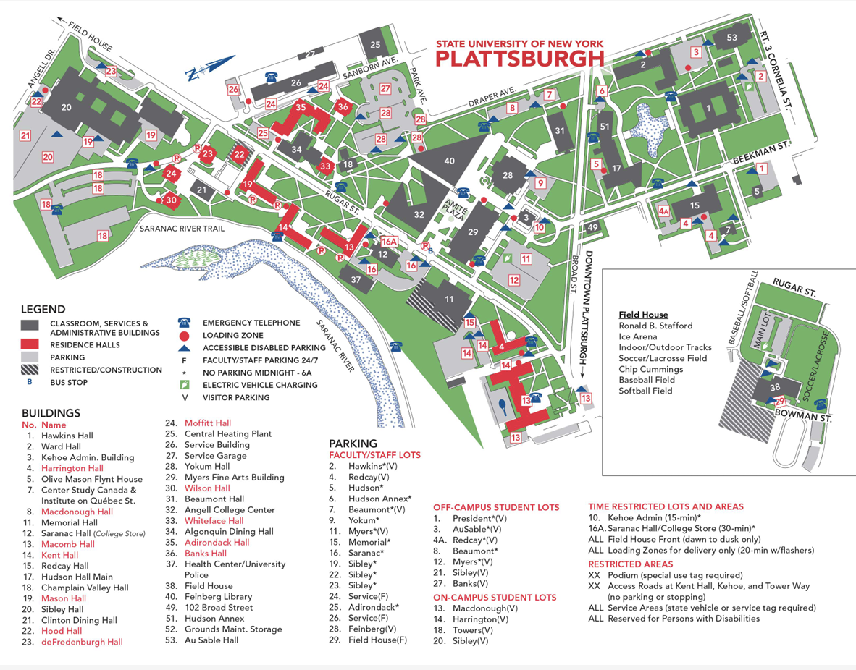
Campus Map

Sponsored By:

